# **Integration**

I = $\int_{a}^{b}{fx.dx}$

# **1) Trapezoidal Rule**

In Calculus, “**Trapezoidal Rule**” is one of the important integration rules. The name trapezoidal is because when the area under the curve is evaluated, then the total area is divided into small trapezoids instead of rectangles. This rule is used for approximating the [definite integrals](https://byjus.com/maths/definite-integral/) where it **uses the linear approximations of the functions.**

The trapezoidal rule is mostly used in the numerical analysis process. To evaluate the definite integrals, we can also use Riemann Sums, where we use small rectangles to evaluate the area under the curve.

Trapezoidal Rule Definition

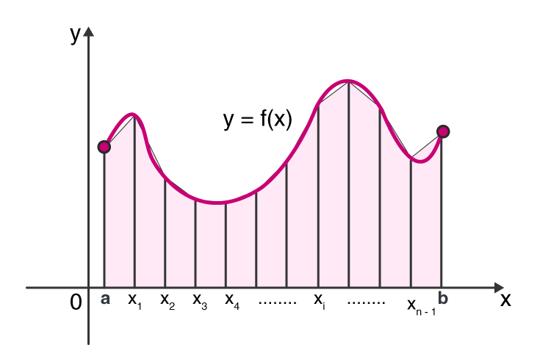

Trapezoidal Rule is a rule that evaluates the area under the curves by dividing the total area into smaller trapezoids rather than using rectangles. This integration works by approximating the region under the graph of a function as a trapezoid, and it calculates the area. This rule takes the average of the left and the right sum.

The Trapezoidal Rule does not give accurate value as Simpson’s Rule when the underlying function is smooth. It is because Simpson’s Rule uses the quadratic approximation instead of linear approximation. Both Simpson’s Rule and Trapezoidal Rule give the approximation value, but [Simpson’s Rule](https://byjus.com/maths/simpsons-rule/) results in even more accurate approximation value of the integrals.

Trapezoidal Rule Formula

Let f(x) be a continuous function on the interval [a, b]. Now divide the intervals [a, b] into n equal subintervals with each of equal width,

**Δx = (b-a)/n,**Such that a = x0 < x1< x2< x3<…..<xn-1 = b

Then the Trapezoidal Rule formula for area approximating the definite integral $\int_{a}^{b}{f(x)dx }$  is given by:

$\int_{a}^{b}{f(x)dx }$ ≈Tn=△x/2[f(x0)+2f(x1)+2f(x2)+….2f(xn−1)+f(xn)]

**X0 x1 x2 x3 x4 (8-0)/4 = 2**

**0 2 4 6 8**

**F(xo) f(x1) f(x2)…….f(x4)**

**Example 1:**

Approximate the area under the curve y = f(x) between x =0 and x=8 using Trapezoidal Rule with n = 4 subintervals. A function f(x) is given in the table of values.

|  |  |  |  |  |  |
| --- | --- | --- | --- | --- | --- |
| x | 0 | 2 | 4 | 6 | 8 |
| f(x) | 3 | 7 | 11 | 9 | 3 |

**Solution:**

The Trapezoidal Rule formula for n= 4 subintervals is given as:

T4 =(Δx/2)[f(x0)+ 2f(x1)+ 2f(x2)+2f(x3) + f(x4)]

Here the subinterval width Δx = 2.

Now, substitute the values from the table, to find the approximate value of the area under the curve.

A≈ T4 =(2/2)[3+ 2(7)+ 2(11)+2(9) + 3]

A≈ T4 = 3 + 14 + 22+ 18+3 = 60

Therefore, the approximate value of area under the curve using Trapezoidal Rule is 60.

**Find out $\int_{0}^{8}{2x.dx}$ using trapezoidal rule with n = 4 intervals.**

**Example 2:**

Approximate the area under the curve y = f(x) between x =-4 and x= 2 using Trapezoidal Rule with n = 6 subintervals. A function f(x) is given in the table of values.

|  |  |  |  |  |  |  |  |
| --- | --- | --- | --- | --- | --- | --- | --- |
| x | -4 | -3 | -2 | -1 | 0 | 1 | 2 |
| f(x) | 0 | 4 | 5 | 3 | 10 | 11 | 2 |

**Solution:**

The Trapezoidal Rule formula for n= 6 subintervals is given as:

T6 =(Δx/2)[f(x0)+ 2f(x1)+ 2f(x2)+2f(x3) + 2f(x4)+2f(x5)+ f(x6)]

Here the subinterval width Δx = 1.

Now, substitute the values from the table, to find the approximate value of the area under the curve.

A≈ T6 =(1/2)[0+ 2(4)+ 2(5)+2(3) + 2(10)+2(11) +2]

A≈ T6 =(½) [ 8 + 10 + 6+ 20 +22 +2 ] = 68/2 = 34

Therefore, the approximate value of area under the curve using Trapezoidal Rule is 34.

2) Simpson’s Rule Formula ( simpson’s 1/3rd rule , simpson’s 3/8)

Simpson’s rule methods are more accurate than the other numerical approximations and its formula for n+1 equally spaced subdivision is given by;

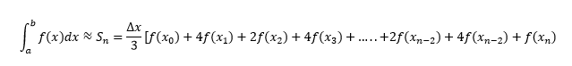

Where n is the even number, △x = (b – a)/n.

If we have f(x) = y, which is equally spaced between [a,b] and if a = x0, x1 = x0+ h, x2 = x0 + 2h …., xn = x0 + nh, where h is the difference between the terms. Or we can say that y0 = f(x0), y1 = f(x1), y2 = f(x2),……,yn = f(xn) are the analogous values of y with each value of x.

Simpson’s 1/3 Rule

Simpson’s 1/3rd rule is an extension of the trapezoidal rule in which the integrand is approximated by a second-order polynomial. Simpson rule can be derived from the various way using Newton’s divided difference polynomial, Lagrange polynomial and the method of coefficients. Simpson’s 1/3 rule is defined by:

|  |
| --- |
| $\int_{a}^{b}{f(x) dx = h/3[(y0+yn) + 4(y1+y3+y5+….+yn-1)+2(y2+y4+y6+…..+yn-2)]}$ |

This rule is known as Simpson’s**One-third rule**.

**Question:** Calculate the integral of the function f(x) = 2x in the interval (0, 2) with n = 6? Or $\int_{0}^{2}{2x}$

**Solution:**

Given,  
A = 0  
B = 2  
Let n = 6

h=b−an=2−06=13

x0=a=0

x1=x0+h=0=13=13

x1+h=13+13=23

x2+h=23+13=33=1

x3+h=33+13=43

x4+h=43+13=53

x5+h=53+13=63=2

x6+h=63+13=1

x7=b=1

y0=f(0)=2(0)=0

y1=2(13)=23

y2=2(23)=43

y3=2(33)=2

y4=2(43)=83

y5=2(53)=103

y6=2(63)=4

According to the formula

∫baf(x)dx=h/3[(y0+yn)+4(y1+y3+….+yn−1)+2(y2+y4+…+yn−2)]

f(x)dx=133[(0+4)+4(23+2+103)+2(43+83+4)]

=1/9[4 + 24 + 16]

=44/9

= 4.89

Calculate the analytical results also and find out the efficiency of simpson’s rule using percentage relative error.Also perform the same question with trapezoidal rule.